Personal Learning Audit: Major Assignment #1 Sections 1-3
Personal Learning/Teaching Journal, Academic Learning Audit, Habits of Mind Audit

Angela McCormick
Educational Administration & Human Resource Development, Texas A&M University
EHRD 630: Adult Learning
Dr. Elizabeth A. Roumell
February 23, 2020

Abstract
This first major assignment for EHRD 630 is a work of personal reflection and analysis. The goal of which is to honestly evaluate learning narratives, practices and ideas both current and former in order to better understand ourselves and benefit from the learning of this course. The assignment includes three sections. The first section is a personal learning/teaching journal serving as a continuous process from day one of the course until its completion. This journal is a place to synthesize ideas and content into professional experiences as well as catalog one’s learning. The following section is an academic learning audit. It looks intentionally into the educational narrative that one has told oneself, where it came from, its accuracy and opens one up to investigate possible areas needing to be revised. Finally, section three is the habits-of-mind audit. This section is a cataloging of real time spent and what one can learn from how one uses the minutes in one’s day regarding the desired outcomes and goals.

Section 1: Personal Learning/Teaching Journal
Journal Entry Week 2
I am loving this class! Reflecting on how my understanding of teaching is being shaped or sharpened as we engage with course material is like trying to catch a runaway idea train. Which means this reflection journal is all the more essential for actual learning to occur! I say a runaway idea train because I feel like each new section we encounter in Learning in Adulthood: A Comprehensive Guide (Merriam, Caffarella & Baumgartner, 2007) is activating new ideas and recalling lived experiences. It is hitting the perfect mark for my current passions and pursuits as it simultaneously gives me vocabulary to understand experiences I have already had in the field of adult education. The broad exposure to various authors, models, and concepts is giving me a framework to analyze my experiences in Community Health Education as well as other adult learning scenarios. I am encouraged by alignment of my previous convictions and the data that many studies are producing. I am being challenged by the vast amount of information I do not yet know. I agree with the editors and many sited researchers in the book when I say that as I learner I come not as an isolated person, but with experiences, cultural assumptions in addition to who I am as an individual. I hope to grow in awareness of when and how I am allowing those aspects to unduly influence my opinions and learning. In the following paragraphs I will try to capture a few things that have stood out to me thus far in the course material and how it's shaping me. Though I feel like I could write volumes.
Illeris's focus in the particular process of learning resonated deeply with me. The "three dimensions involved in learning-- cognition, emotion, and society" (2007, p.97) are represented on an inverted triangle and while they are not necessarily evenly emphasized, they are always present according to Illeris. My training and experience in adult language training/ learning immediately was drawn to mind while reading this section (though in my trainings I add the physical dimension and the spiritual dimension as additional points in the learning process). The distinct yet the interplaying nature between the dimensions and how they augment or impede learning/performance resonated with me. The limbic system is a key place where we can observe the interplay of Illeris's learning dimensions as it houses at its deepest level the amygdala as well as the hippocampus and social processing center (and more).
In her book Emotion: the on/off switch for learning, Priscilla L. Vail describes the limbic system’s job of interpreting the emotional value of incoming stimuli and comparing it to a functioning elevator (Vail, 1993). "The limbic system broadcasts its interpretation out over the whole body, and depending on its interpretation, either opens or closes access to higher cortical function, the top stop. If the limbic system says “Trouble” … access shuts down. The elevator doesn’t reach the higher level... Conversely, if the limbic system says “Great!”, the elevator smoothly ascends to a penthouse of knowledge, imagination, and creativity. Emotion controls the elevator." (Vail, 2009). For example, a colleague of mine living in Arabic speaking North Africa had a couple difficult encounters with her neighbor about who’s intended to keep the stair well washed at the beginning of the week. When the doorbell rang on Wednesday and it was her neighbor Fatima’s voice on the other side of the door, my colleague's stomach turned and her mind went blank. Not because of not working hard enough during her language lesson earlier that day, it was completely an emotional block. I could provide positive examples too. I appreciate the simplicity of Illeris's model because it analyzes with ease where a learning block might be and problem solves with greater precision.
I also appreciated Jarvis's learning process which outlines the transformation of a person through their experience. Figure 4.2 (2007, p.101) easily shows the interconnectedness of emotions, thoughts, actions, within a social context all bounce and influence the final data that a person ingests and incorporates. The cyclical aspect of incorporating new data from new experiences and becoming in some ways a new version of oneself only to repeat process seems to cast a considerable amount of importance on one’s ability to engage and process experiences in a healthy manner. This is where the impacts of the ACE studies we saw Dr. Nadine Burke Harris present in her TED talk and Bessel Van Der Kolk M.D presents in The Body Keeps the Score play a critical role. Van Der Kolk says, "traumatized people become stuck, stopped in their growth because they can't integrate new experiences into their lives." (Van Der Kolk, 2014) This would effectively truncate all their learning according the Jarvis' learning process model.
I'll have to stop there for this entry, you have other things to read!

Journal Entry Week 4
A powerful marker in education is narrative. I have experienced the benefit of a strong personal educational narrative thanks to hard working and educated parents, well performing older siblings. My mother's work in the K12 educational field in minority majority schools throughout Texas has exposed me to the opposite. Stories are still powerful, and equally in negative and disabling ways as positive and strong. The stories that people are telling themselves is of critical importance for educators of any age. I have utilized the power of story in my own professional setting and can attest to its multi layered benefits. Through the readings I appreciated new facets and was reminded of reinforcing studies/stories as well.

In Halqa, our community health education program, we begin each lesson with a story. A health principle is taught in story form, sometimes allegorical, sometimes in theatrics, always using a culturally relevant frame and familiar stories to convey a more complex topic. Using the language of Baumegartner & Merriam as captured in Learning in Adulthood (2007) our narrative use most commonly fits into the second form, "fiction, case studies, exemplars from practice, role-playing, or critical incidents-" (2007, p 210). Since one of our explicit goals is the easy transmission of these health principles to others in the community stories are excellent facilitators because they are easy to recall and retell. Thus the information is held without effort and transmitted with the simple skill of gossiping!
The third form of narrative (2007, citing Baumegartner & Merriam, 1999) I see as a great personal development skill as well as a great skill for educators to foster in their classroom or teaching environments (like this assignment!). In addition to the skill of capturing a particular narrative this tool also allows the tools for changing the narrative. If the story is never captured it is more difficult to restory or alter. I see aspects of this restorying potential in Boud, Keohg and Walker's model which three stages include "returning to and replaying the experience, attending to the feelings that the experience provoked, and reevaluating the experience." (2007, p. 165). I recently listened to a podcast about a short-term therapy for trauma called cognitive processing therapy (Glass & Lowe, 2019). It was specifically designed for veterans with PTSD and for survivors of sexual assault. The podcast is a recording of the journalist Jaime Lowe herself going through the therapy. I was astonished to observe how her "story" changed and how that change, empowered and impacted her and the listener. It is a superb example of the power of narrative and the stories we tell ourselves.
Randall also uses that term "restory" to refer to what needs to happen when we have an experience that does not fit into our existing story. Glover cites Randall referring to "how I can compose a story big enough, with a horizon broad enough, to account for as much as possible of my actual life and render it available to me as a coherent, re-membered whole." (2007, p. 214-215). One temptation might be to have a horizon broad enough that it can accommodate anything to avoid the need to restory, but I think adult learning theory shows us that the learning is actually in the restorying, not the wide horizons. And my experience of maturity in adulthood in myself and my friends is in the thoughtful precision of convictions and ideas and the willingness to reflect and research when we encounter the limits of those. Willingness to restory is a marker of maturity. I am reminded of a TED talk (Bowler, 2018) who excellently demonstrates how personal experience and honest reflection can open up oneself to restorying in a compelling manner. Narratives are a tool in teaching and a critical tool in learning. The observant educator and the active learner can both benefit from the advantages and assistance available through story.

Section 2: Academic Learning Audit
What is learner identity? And what does it matter? Learning is a process, and a personal one at that (Merriam, Caffarella, Baumgartner, 2007, p. 1)! A process takes place over time and space and in this context that space is a person and that time is their life. In order to have a holistic understanding of learning it cannot be separated from the subject engaged in so doing. "Learning is a process that brings together cognitive, emotional and environmental influences and experiences for acquiring, enhancing, or making changes in one's knowledge, skills, values and world views (Merriam, Caffarella Baumgartner 2007 citing: Illeris, 2000 Ormrod, 1995). Learning helps to form our identity simultaneously as our individuality informs and influences our learning. Identity as equal to individuality is defined as "the sum of qualities that characterize and distinguish an individual from others" (Merriam-Webster, 1998. p. 266). Our identity is the what/who the process of learning acts upon and forms. And our learner identity, more specifically, is the narrative of who we are formed into in that process. Many authors have written on the role and power of narrative in our learning environment, but it is specifically Dominice that ingrates the role of "educational biographies" to "help adults clarify the future they want to build" (Merriam, Caffarella, Baumgartner, 2007, p. 211-213. citing: Dominice, 2000). In this paper I will reflect on the formation and the evolution of my learner identity through the lens of my family of origin, my K12 education, my higher education, my "real-world" experience as well the social and psychological tools that have helped me to understand my personal formation. Through this examination I will gain awareness and be able to better engage with learning in this setting and profit from the program with greater clarity and confidence for the future I want to build.

My family of origin has influenced my life in innumerable ways including my learner identity. I come from a hard-working German family. My parents met as an undergraduate student taking a class from a graduate student, and I think the subtle narrative in our family of "life is what happens while you are learning" was present in part due to how they met. My father nearly finished his PhD in physics before taking a different career path, and my mother modeled formal lifelong learning while working and mothering. She completed her second master's degree in educational leadership in 1992 and her Doctor of Education in 2009. In addition to the example set by my parents I was also impacted by my siblings. I was the youngest of three daughters and my older sisters exceled academically. Growing up in a small town augmented the influence of my family of origin because everyone knew my parents and I shared many of the same teachers as my sisters. This communal knowledge of who my family is resulted in a social net or pressure to uphold the standard erected by them. At times the expectation of performing at a certain level was more pronounced than any performance I produced. I do not think any teachers gave me grades I didn’t earn, but I do think they began the grading process expecting a certain level and it would have taken a significant disparity for them to shift that expectation. My family of origin influenced my learner identity in that the expectation of myself and others was to perform well, work hard and excel academically in all subjects. We had a reoccurring mantra of you can do whatever you want to do if you try.
In elementary school I recall being tested and subsequently being pulled out of my regular class a couple of times a week to go into the "gifted and talented" class (A brief aside, it was a text book for embodied learning and I loved it!). This distinction lead me to prize curiosity over knowledge and expect high academic results of myself. I graduated from my high school 10th in a class size of 181 students. I do not recall that being something that I worked for, but I do recall being proud of it. On January 18th, during our first class, Dr. Roumell made the statement that a good student does not necessarily equal a successful learner. In many aspects that truth could be used to describe my secondary education. I was a good student in that I received good marks and easily navigated assignments and studies, but how much I learned seems paltry in comparison. Academic skills I mastered in high school were strongly in the performing arena of academia with oral reports and creative learning far outweighing the counter parts of data understanding, integration and even standardized tests. Looking at my grades reinforces my memory of doing well enough to be a good student, but upon reflection it reveals that I was doing what I needed to get a grade, not to learn. My get by approach begins to show cracks if one looks at my English grades as the semesters progressed. My grades were ENG 1: 93-94, ENG 2: 92-88, ENG 3: 91-89, AP ENG LIT: 86-86. It's not that AP ENG LIT was disproportionately harder than the previous course, but it was more so that my skills of reading and understanding "enough" of the text was not sufficient for writing reflective papers and understanding the intents and minds of some of the English world's best writers. Looking back, I am saddened that such great literature was wasted on me before I knew how to appreciate the art of novels. My ACT (26), PSAT (149), SAT(1070), TAAS scores all reveal that I had mastered a lot of material and could reproduce it on tests but my recollection of those experiences emotionally were that I should do well enough without trying. Which in my young arrogance meant I didn’t know how to ask for help for understanding deeper principles. My K12 learner identity formed in me that idea that I was naturally capable and should do okay as long as I show up. I felt insecure in actual "learning" because actual learning requires humility and an openness to be formed by the subject. Despite my insecurity in learning I performed well in the educational system.

The opportunity to go to one of the largest universities was a great tool to level the external benefits of my family of origin. This was the first time in education that I didn’t come with the shadow of my sisters or my parents. My education was to be my own. University education afforded me the opportunity to have a greater influence on the courses I wanted to take, and I enjoyed tasting new areas of study. It was also the first time I really had to work to earn a grade and the first time that the hollow learning structures from my earlier years were shown for their inadequacy. My first fall semester, CHEM 301: Principles of CHEM/BIOCHEM was killing me and I worked hard to earn the C my professor gave me. I also recall running to office hours to change 408C Differential and Integral calculus to Pass Fail in order to save face of likely earning another C. But the effort and ownership of my undergraduate studies introduced me to personal passions and resources I had not previously uncovered. It was through following those passions I discovered and fell in love with learning about linguistics, and anthropology, environmental sciences and geography, Arabic, astronomy, history, maps, et cetra. Learning became a feast and a fun discovery. Each class was a new professor, new classmates, new ideas, new worlds and I loved the challenges that each newness presented. I recall learning to read in the opposite direction in Arabic and sensing that a my brain had uncovered an entire new way of processing information. I loved the idea of yet more undiscovered ways of thinking and seeing life. In my undergraduate studies I often say I wasn't undecided regarding my major, I was over decided. Each new experience would send me down the track of exploring how that field would look and what major I could pursue to follow it. Looking back now with greater vocabulary for adult learning I see how the role of personal reflection and application of the abstract lessons reinforced the information strong emotional bonds. For example, I recall in GRG 335K Mountain GEOECOLOGY making personal notes about the parallel social and spiritual correlations as I learned how flora changes as you increase in elevation, go up a mountain. I am confidant my recollection of the class material was enhanced because I had mused about metaphorical applications. My learner identity was humbled in this season to realize I needed to do more than show up, I also needed to engage with the material presented and examine it from multiple angles before assuming I could answer a few test questions. Initially bruised through running into awareness that I was not sufficient left to my known resources, but overall I grew through those years. Objectively, I maintained a learning affinity towards experiential, integrated and people centric learning while maintaining an aversion to numbers and details.
The "real world" has been an uninterrupted classroom for me. In large part due to my work overseas and the need for constant learning and upgrading of skills linguistically, culturally and professionally. I learned about myself that instant application is the best arena for growth and retention of information. Years of studying the Spanish language did not accomplish near as much fluency as a few months living with a Moroccan family and needing to speak Arabic for my daily needs. My learning has been primarily, though not exclusively, non-formal and informal in nature since my undergraduate degree. The arenas of my learning have been varied: from language and cultural acquisition, to team building and organizational development, adult learning and transformational development, to cross cultural living and coaching. All this learning was heavily motivated by a clear and meaningful "why" as well as a "just in time" need as oppose to a "just in case" possibility. When I connect what I am learning to who or how I want to be my learning makes significant strides ahead. Immediate application and the ability to see growth and development over time also meant that my learning had significant positive feedback from others in the form of praise for my acquired level of linguistic skill as well as the positive results in my work. In regards to how my "real world" classroom has impacted my learner identity I can see ways it reinforced my self-perception that learning which involves people, practice, and impromptu skills is an area of strength while areas of dates and details remained a background weakness. My real world learning environment also introduced me to scores of people who did not have the educational opportunities that I had been given and entering into their world allowed me to appreciate and benefit again in some ways from things I had previously taken for granted. Gratitude has become a key component for my learner identity now that influences how I engage with information and opportunities.
Various personality and typology theories have assisted me to greater understanding of myself as well as increased empathy towards others. Understanding my extroverted nature and how it assists in reinforcing learning as I’m drawn to process what I’m learning with others has been an asset. Enneagram language lends insight to my predisposition to be future centric and endlessly connected to possibility. The same has also shown me the limitations and immaturity of hope without critical reflection. Gallops strength finders study showed me my drive for input and ideation as well as activation. I like to move, and I like to motivate others as I go. My training and studies in orality have increased my understanding in the learning advantage of narrative, social groups and repetition. These tools, among others, have given texture and breadth to my learner identity. Revealing that learning happens on many levels and accessing it with different parts of my personal identity allows it influence to varying degrees of my whole person.
Putting it together, what does it mean for this class and this graduate program as well as my current professional opportunities? In part it means I am exhausted by all there is around me to learn! This class has many elements and details that I find applicable and interesting that I am finding it difficult at times to cover the material I need to cover in the time frame. Some of the slowness results from forming new normals as this is my first semester in graduate school and I am on a steep learning curve of how to engage in formal learning again. Another cause for the decreased speed is my high interest in the material and the processing time required to read, reflect and retain the information. My immediate application points based off of this academic audit of my learner identity are to not shy away from asking questions when I do not understand something, specifically as it relates to me learning the new systems of formal graduate studies. Another is to continue to strive for application of the new insights into my professional role or at minimum talk about what I am learning with my colleagues and work teams. A final takeaway is to remember the “why” in this degree for me. Part of my learning ritual is a quieting exercise that includes a visualizing of the people that my efforts will support, serve and equip. It is not to learn new tricks of the trade or simply get a degree that says I know something, but I really want to better equip myself to be able to better equip the amazing men and women I work with to be their best selves.

Section 3: Habits-of-Mind Audit
Tracking my time this month has been a challenging activity. In part, it was problematic because I do not have the habit to do so, but more so because my time is malleable, interrupted, and heavily self-determined. I do not have a “clock in clock out” type of job (identified in yellow/orange in the graphs below). I am involved in projects and teams that are entrepreneurial by nature and partner with people all over the globe. My professional life is heavily impacted by my stage of life and my family choices of being invested and involved in my children’s lives. Case in point, their school’s two-week break in February dramatically impacts my productivity on all front and it reflected in this month’s time tracking assignment. An additional factor to the use of my time is my cross-cultural lifestyle which can mean that administrative tasks require more time for me here than if I was living in my passport country. But despite these challenges I appreciated the challenge of tracking my time and I learned a lot from greater awareness in this area.
Globally speaking, I was able to see major areas of time spent. Seeing allowed me to acknowledge and adjust either in my schedule or in my perspective. Tracking the hours I spent in “domestic delights” (a euphemistic title to help increase the joy!) (colored in grey), allowed me to see how much time goes into caring well for my family and making our home a great place to be. That is important to me. It also gave me the insight that it is a significantly untapped resource. There are aspects of my domestic delighting (cooking & cleaning primarily) that lend themselves towards multitasking either with language immersion listening or other intentional podcasts. Additionally, I’d like to develop the intentional activity of a thought assignment during those responsibilities where my hands are active, but my mind is free. Another area of my life that owns a significant percentage of my day is parenting (colored below with the color purple). And parenting has rich rewarding aspects as well as mundane repetitive tasks. Tracking my time in this area illuminated opportunities for greater intentionality, as well as times that can overlap with other needs like inviting a child to help me cook. Connection, conversation, and training time with my boys are great habits to build into household activities as well as play. Tracking my time had an unexpected accountability effect as well. I am not on social media, but I do like to read the news during those minutes of waiting when I imagine others would look at their feed or wall etc. Tracking my time made me think twice about pulling up the New York Times of The Post. It made me more productive with those minutes, because I didn’t want to have to log those minutes of “reading the news” on my chart. Looking specifically into my learning and personal development (marked by green below) category I benefited from the initial step of making a list of what activities that are included in this category. Articulating specific activities that are forming me more into whom I’d like to be caused me to be engaged in moments where I had in previous months been passive. For example, I am currently learning French, and I was able to identify times in my week that could be used for intentional French conversation practice. With a specific regard towards EHRD 630, I have learned that I must be intentional in progressing through the class assignments. I am easily distracted; it takes me longer to get into a focused study groove than I’d like to admit. I have learned that ear plugs are helpful, as are prepared snacks like nuts and fruit to prolong my ability to sit and wrestle through a reading or a though assignment. My learning ritual has been an excellent teacher and I have adjusted it throughout the past several weeks. I need my learning ritual to be flexible and but my posture to be steady. In February I will have had two international travels, hosted my mother, trained two cross cultural teams, as well as domestic travel all while working, parenting and applying for our visa renewals. So, my Monday evening green tea and quieting sometimes looked different, sometimes they were an early morning flight across the Mediterranean, but it always found its place. The two remaining areas tracked but not commented on here are exercise (red) and leisure time (brown). Both of which are both priorities for me.
The following graphs and calendars represent these first weeks of February tracked by the application ATracker on my phone.
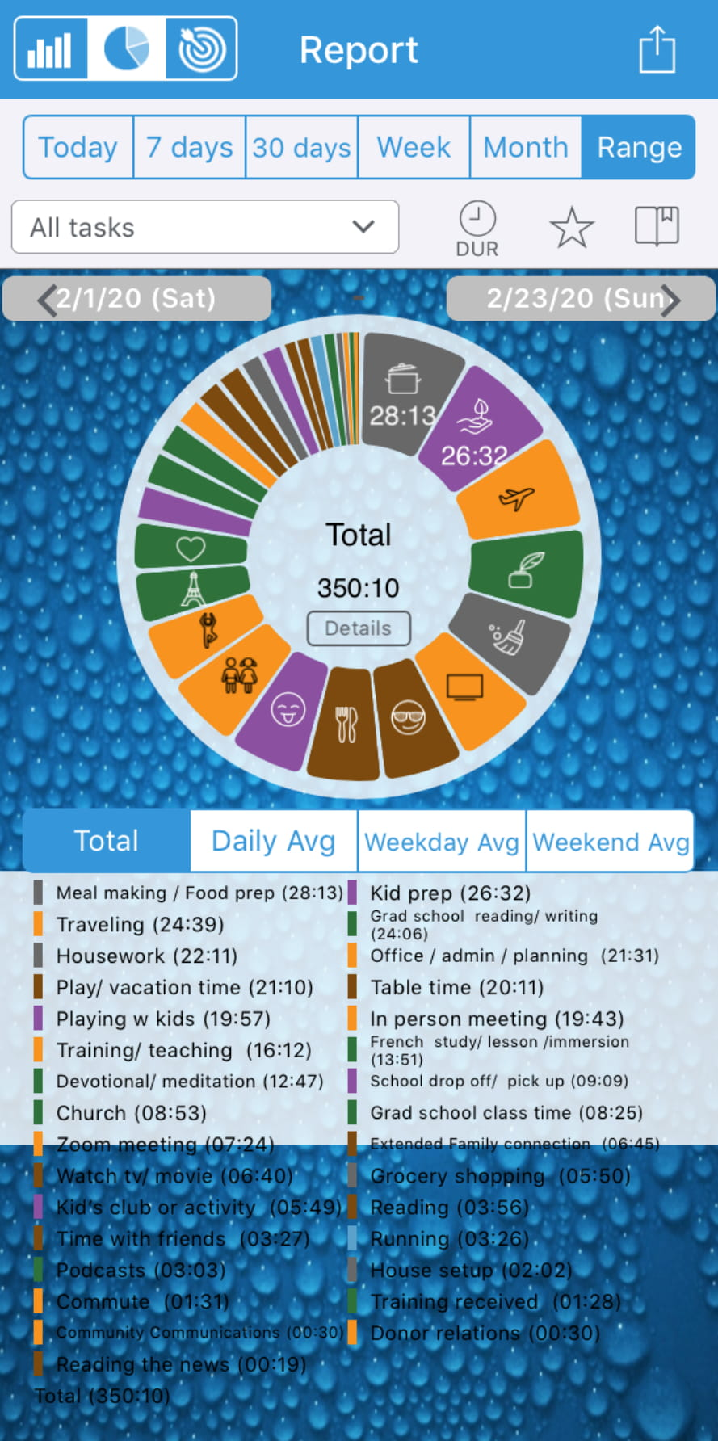
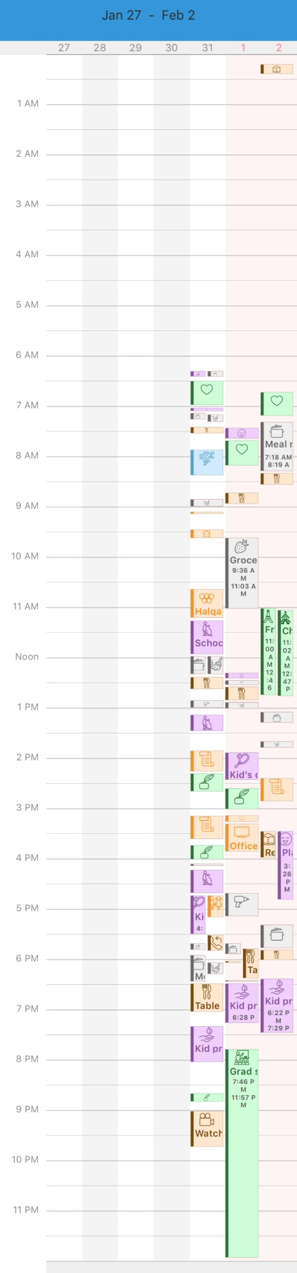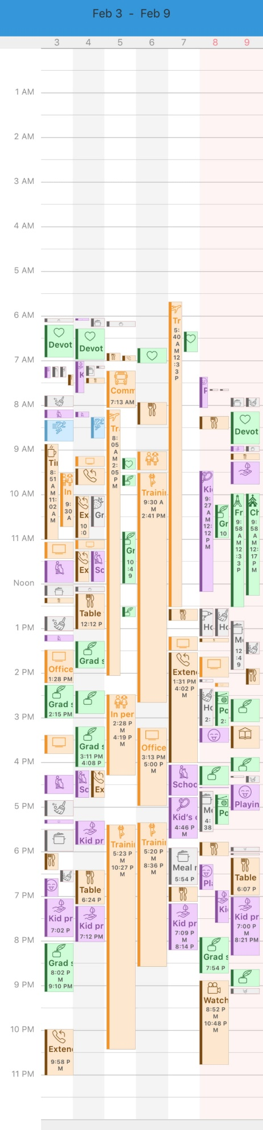
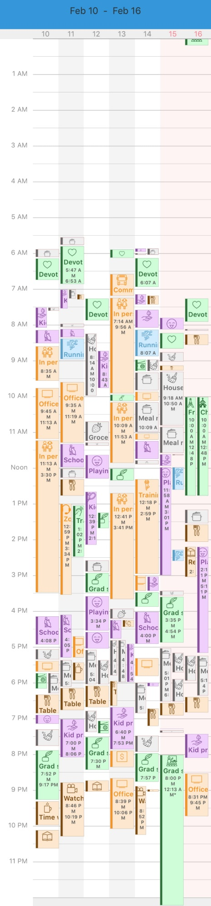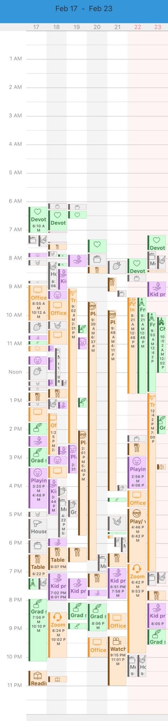
References
Bowler, K. (2018 December). “Everything happens for a reason”—and other lies I’ve loved [Video]. TEDMED. https://www.ted.com/talks/kate_bowler_everything_happens_for_a_reason_and_other_lies_i_ve_loved?language=en
Glass, I., & Lowe, J. (Hosts). (2019, August 23). Ten Sessions (No. 682) [Audio Podcast Episode]. In This American Life. WBEZ Chicago. https://www.thisamericanlife.org/682/ten-sessions
Merriam, S., Caffarella, R., & Baumgartner, L. (2007). Learning in Adulthood: A Comprehensive Guide (Third Edition). San Francisco, CA: Jossey-Bass.
Merriam-Webster. (1998). The Merriam-Webster Dictionary. Springfield, Massachusetts. Merriam-Webster, Incorporated.
Vail, P.L., (2009, May 15). The role of emotions in learning. Great Schools. https://www.greatschools.org/gk/articles/the-role-of-emotions-in-learning/
Vail, P.L., (1993). Emotion: the on/off switch for learning. USA. Modern Learning Programs.
Van Der Kolk, B., (2014). The Body Keeps the Score: Brain Mind, and Body in the Healing of Trauma. USA: Penguin Books.

